Support Vector Machines
Teaching Notes
A from-scratch, no-assumptions guide to how SVM actually works, written for someone who has never seen it before. Every idea is built up from plain intuition first, then the matching math in simple algebra, with a diagram at every step.

Contents

1. The Problem SVM Solves
Imagine you have two groups of points on a page, two classes, and you want to draw a boundary that separates them, so that anything new can be classified by which side of the boundary it falls on.
The immediate problem: usually there isn't just one boundary that works. Look at the picture below, every one of those dashed lines separates red from blue perfectly. So which one should we actually pick?
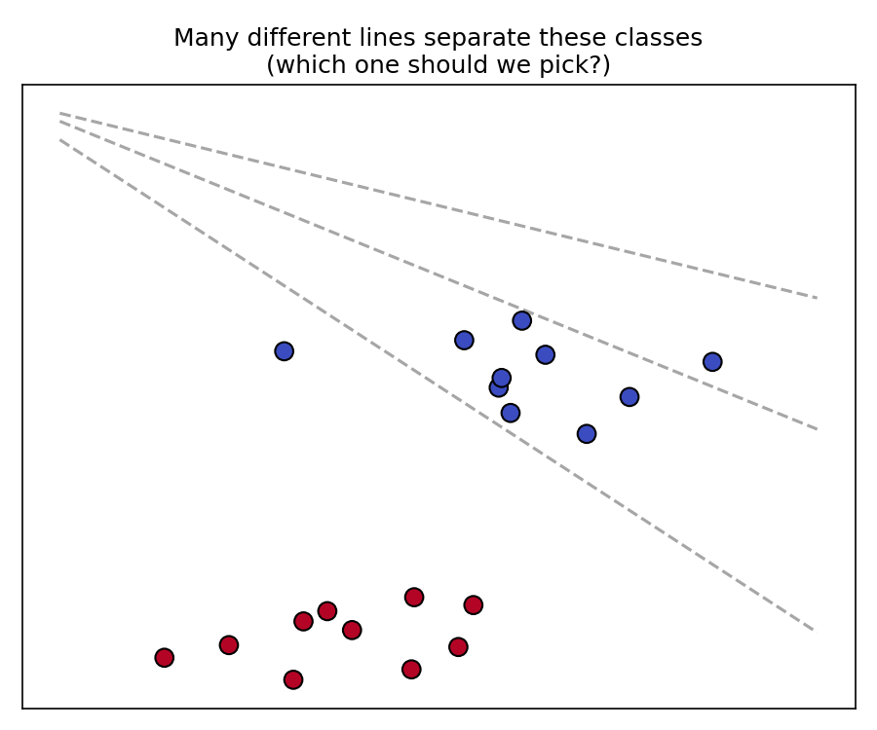
Figure 1. Several different lines all separate these two classes correctly.
SVM's answer: out of every line that separates the classes, pick the one that stays as far away as possible from both groups. Intuitively, a line that barely squeezes between the two groups is fragile, a new point only slightly different from what we've seen could easily land on the wrong side. A line with plenty of breathing room on both sides is safer.

2. Margin and Support Vectors
The gap between the boundary and the nearest point of each class is called the margin. SVM picks the boundary that makes this margin as wide as possible, this is called the maximum-margin classifier.
The points that end up exactly on the edge of that margin (the closest points from each class) are called support vectors. They are the only points that matter for defining the boundary, if you deleted every other point and re-trained, you would get the exact same boundary. That is also where the name “Support Vector Machine” comes from.
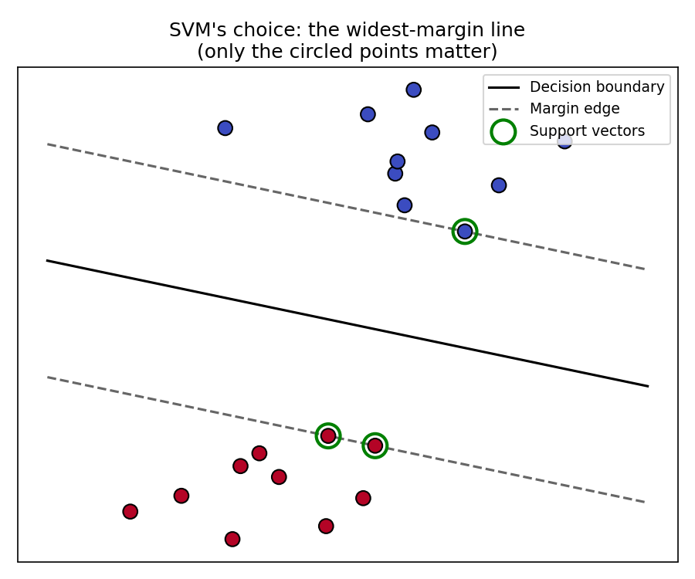
Figure 2. SVM's chosen boundary: the widest possible margin. Only the circled support vectors define it.
Notice: out of 20 points, only 3 are circled as support vectors. The other 17 could move around freely (as long as they don't cross into the margin) and the boundary wouldn't change at all.

3. The Math of the Boundary
You already know the equation of a straight line in 2D: y = mx + c. SVM writes this in a slightly more general form that works in any number of dimensions, however many features your data has:
w · x + b = 0
- x is a data point (a row of feature values).
- w is a vector of weights, one per feature. It controls the direction/tilt of the boundary, just like the slope m does for a 2D line.
- b is a single number that shifts the boundary, just like the intercept c does.

To classify a new point, we just check which side of the boundary it is on:
predict class +1 if w · x + b ≥ 0, predict class −1 if w · x + b < 0
That is the entire model, just the numbers stored in w and b.

How Wide Is the Margin, Exactly?
It turns out (we will just state this fact rather than derive it) that the width of the margin is exactly:
margin width = 2 ÷ ||w||
where ||w|| is simply the length of the vector w (ordinary Pythagoras: if w = (w₁, w₂), then ||w|| = √(w₁² + w₂²)).
Since the margin is 2 divided by ||w||, making the margin as wide as possible is exactly the same thing as making ||w|| as small as possible. So the entire training problem becomes:
minimize ||w||, subject to every point being correctly classified with at least 1 unit of safety margin
Written out, that constraint is: for every training point (xᵢ, yᵢ), where yᵢ is either +1 or −1,
yᵢ × (w · xᵢ + b) ≥ 1
This one formula covers both classes at once. If yᵢ = +1, it requires w·xᵢ + b ≥ 1 (comfortably on the positive side). If yᵢ = −1, it requires w·xᵢ + b ≤ −1 (comfortably on the negative side). Multiplying by yᵢ is just a trick to write both cases in one line.

4. A Tiny Worked Example
Let's plug in actual numbers, in 1 dimension, to keep the arithmetic trivial. Say x = 3 belongs to class +1, and x = 1 belongs to class −1. Try the boundary w = 1, b = −2 (so the boundary sits at x = 2, exactly halfway between them):
- For x = 3 (class +1): w·x + b = 1×3 − 2 = 1. Check: yᵢ(w·xᵢ+b) = 1×1 = 1 ≥ 1 ✓
- For x = 1 (class −1): w·x + b = 1×1 − 2 = −1. Check: yᵢ(w·xᵢ+b) = −1×−1 = 1 ≥ 1 ✓

Both constraints come out to exactly 1: both points sit exactly on the edge of the margin, they are the support vectors. The margin width is 2 ÷ ||w|| = 2 ÷ 1 = 2, matching the gap between x=1 and x=3. If we had instead picked a steeper w = 2, the margin would shrink to 2 ÷ 2 = 1, narrower and less safe, exactly why SVM prefers the smallest w that still satisfies every constraint.
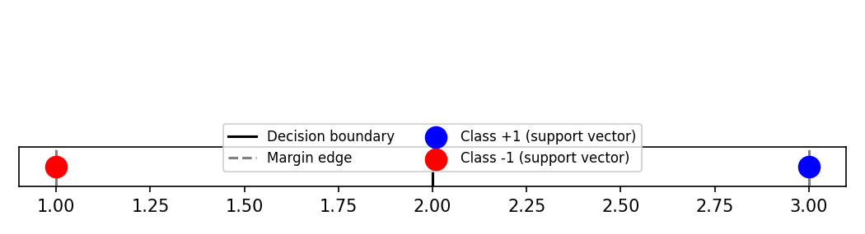
Figure 3. The tiny worked example: margin width = 2, both points sitting exactly on the margin edge.

5. Soft Margins: When Data Isn't Perfectly Separable
Real data is messy. Sometimes a few points will end up on the wrong side, or inside the margin, no matter where we draw the line. SVM handles this by relaxing the rule slightly: each point i is allowed a small “cheat” amount ξᵢ ≥ 0 (a slack variable):
yᵢ × (w · xᵢ + b) ≥ 1 − ξᵢ
If ξᵢ = 0, the point follows the original strict rule. If ξᵢ > 0, it is allowed to sit inside the margin, or even on the wrong side, by that amount. We do not want unlimited cheating though, so we penalize it in what we are minimizing:
minimize ||w||² + C × (sum of all the ξᵢ)
C is a number we choose (a hyperparameter), and it controls the trade-off:
- Large C: cheating is expensive, so SVM tries hard to classify every point correctly, even if that means a narrower margin. Risk: overfitting to noisy points.
- Small C: cheating is cheap, so SVM keeps a wide, stable margin even if a few points end up misclassified. Risk: underfitting.

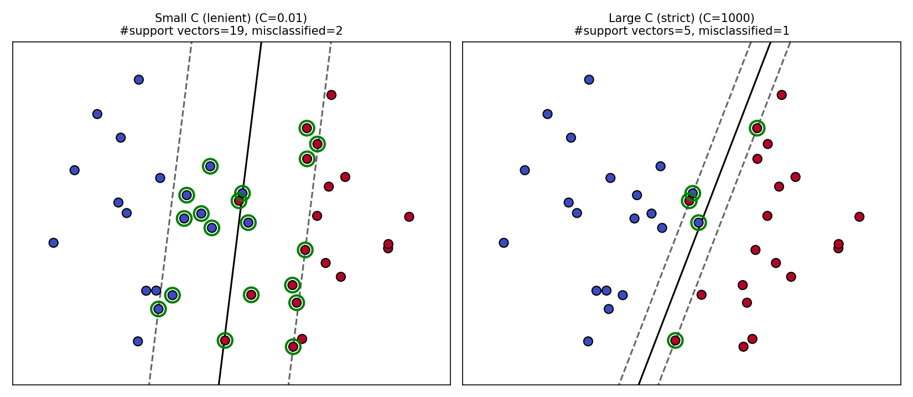
Figure 4. Same data, same kernel, only C changed. Small C keeps a wide margin with more tolerated mistakes; large C narrows the margin to correct more of them.
With small C, the margin is wide and 19 points end up close enough to count as support vectors, and 2 points are misclassified in exchange for that stability. With large C, the margin narrows sharply, fewer support vectors, and it manages to correctly classify one more point, at the cost of a boundary that is more sensitive to exactly where these particular training points happened to fall.

6. Non-Linear Data: Why We Need Kernels
Everything so far assumes a straight boundary works. But sometimes it just does not, no matter how you tilt or shift a straight line, some datasets cannot be separated by one. Here is the simplest possible example: points on a single number line, where the two classes are interleaved by distance from the center.
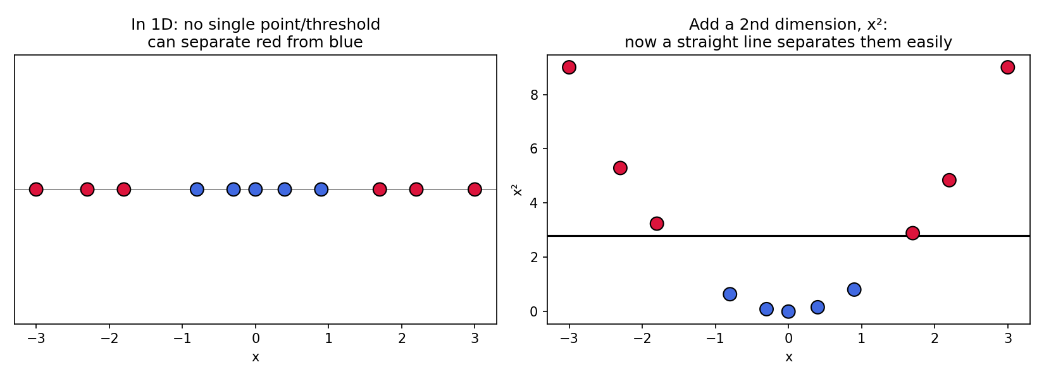
Figure 5. Left: impossible to separate on a single number line. Right: trivial once we add a second dimension, x².
That is the entire idea behind kernels, in one picture. If the data is not linearly separable in its current dimension, lift it into a higher dimension where it is. Here, simply adding x² as a second coordinate turned an impossible 1D problem into a trivial 2D one, a single straight line does the job.
The catch: figuring out the right transformation, and actually computing it, can be expensive or even impossible (some useful transformations lead to infinite dimensions). That is exactly the problem kernels solve, they let SVM get the effect of this lift without ever computing it directly (more on the mechanics in Section 8).

7. The Common Kernels
Let's see this play out on a harder 2D example: two concentric circles, one class forms a ring around the other. No straight line can separate these, so this is a perfect test of what each kernel can actually do.
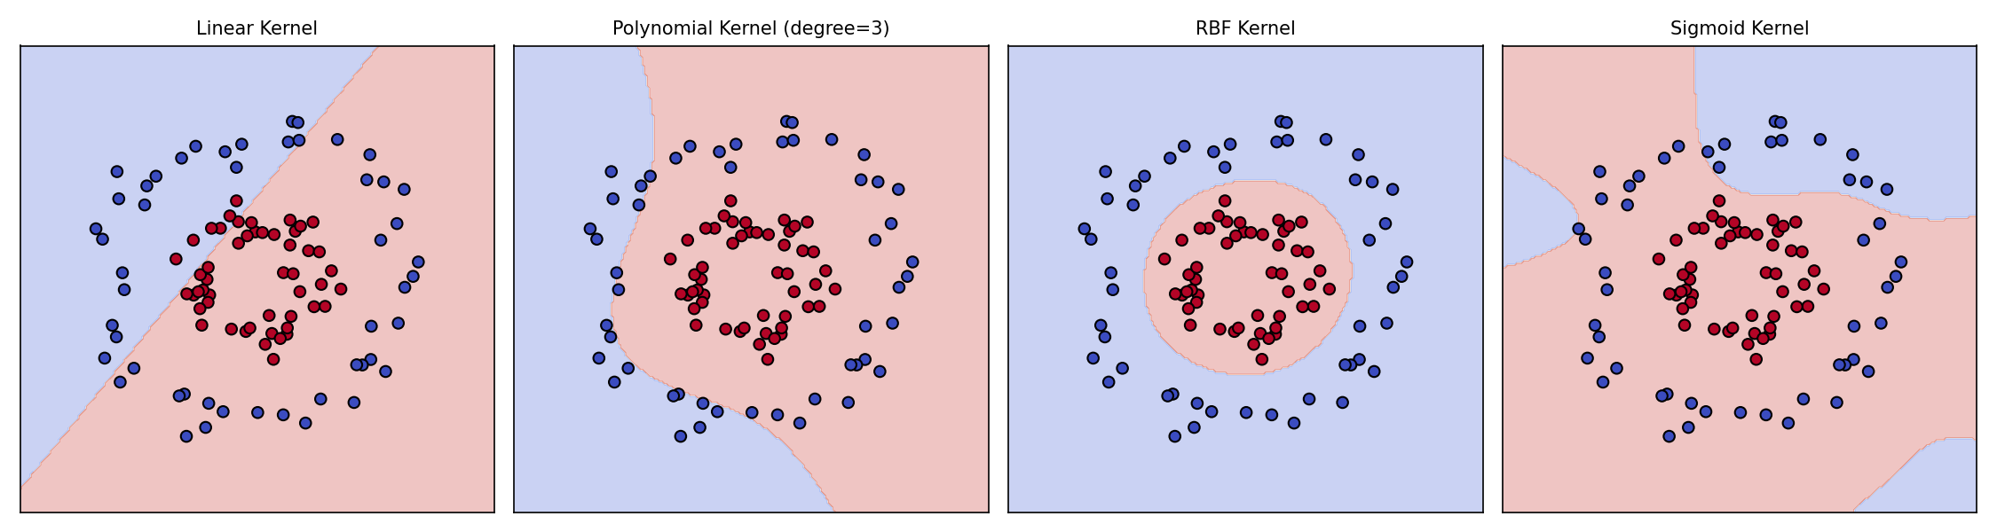
Figure 6. The same two-circles data, separated by four different kernels.
- Linear completely fails here, as expected: there is no straight line that separates a ring from its center.
- Polynomial (degree 3) manages a rough, blocky curve.
- RBF does this almost perfectly: a clean circular boundary tracing the inner circle. This is exactly the shape its distance-based similarity is naturally suited to, which is why it is scikit-learn's default kernel.
- Sigmoid produces a messy, disconnected boundary that barely captures the circular pattern at all, a good visual reminder of why it is used far less often in practice.

The formulas behind each:
Kernel | Formula | Plain-English meaning
Linear | xᵢ · xⱼ | No transformation, straight boundary
Polynomial | (γ xᵢ·xⱼ + r)^d | Adds curved, polynomial-shaped boundaries
RBF | exp(−γ||xᵢ−xⱼ||²) | Similarity based on distance, smooth curved boundaries
Sigmoid | tanh(γ xᵢ·xⱼ + r) | Neural-network-like, less predictable boundaries

8. Why Kernels Work: A Peek Behind the Curtain
This is the one part of SVM that looks like magic until you see the mechanism, so let's open it up gently, without the full derivation.

Every Training Point Gets an Importance Weight, Alpha
When SVM is trained, it does not just produce w and b. Behind the scenes, it also assigns every single training point a number αᵢ ≥ 0 (this comes from a technique called Lagrange multipliers, we will not derive it, just use the result). This number says how much “influence” that point has on the final boundary.
The key fact: for every point that is not a support vector, αᵢ works out to be exactly zero. Only the support vectors get αᵢ > 0. That is the precise mathematical reason only support vectors matter, every other point's weight in the final formula is multiplied by zero.
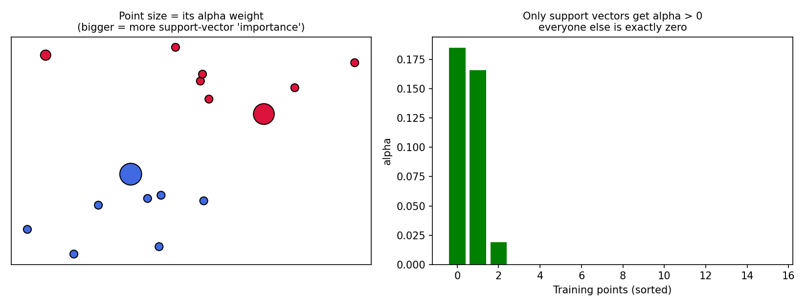
Figure 7. Left: point size shows its alpha weight. Right: only support vectors (green) have alpha above zero, everyone else is exactly zero.

Why This Makes the Kernel Trick Possible
With these αᵢ weights, it turns out the entire trained model, both fitting it and using it to predict, can be rewritten so that the data points only ever appear in pairs, multiplied together (as a dot product xᵢ·x), never on their own. Roughly:
prediction for a new point x = sign( Σᵢ αᵢ yᵢ (xᵢ · x) + b )
Look closely: xᵢ·x is just a dot product between a training point and the new point. Since αᵢ = 0 for every non-support-vector, this sum only really involves the support vectors.
Now recall from Section 6 that solving a non-linear problem means lifting every point into a higher-dimensional space with some transformation ϕ, i.e. replacing x with ϕ(x) everywhere. If we did that literally, the formula above would need ϕ(xᵢ)·ϕ(x) instead of xᵢ·x, computing ϕ for every point.
The kernel trick: a kernel function K(xᵢ, xⱼ) computes ϕ(xᵢ)·ϕ(xⱼ) directly, without ever computing ϕ itself:
K(xᵢ, xⱼ) = ϕ(xᵢ) · ϕ(xⱼ)
So all we do is swap xᵢ·x for K(xᵢ, x) in the prediction formula above, and we get all the benefit of the higher-dimensional space (even an infinite-dimensional one, in RBF's case) at the computational cost of working in the original space. That swap is the entire “trick”.

9. Multi-Class SVM, Briefly
Everything above assumes two classes (+1 and −1). Most real problems have more. Scikit-learn handles this automatically using one of two strategies:
- One-vs-Rest (OvR): train one binary SVM per class (“is it class A or not?”, “is it class B or not?”, ...), and predict whichever classifier is most confident.
- One-vs-One (OvO): train one binary SVM for every pair of classes, and let them vote. This is what scikit-learn's SVC uses internally by default.

You do not need to configure this yourself, just be aware it is happening under the hood whenever your target has more than two classes.

10. Strengths, Weaknesses, and When to Reach for SVM

Strengths
- Works well even with a high number of features relative to the number of rows.
- The kernel trick makes it genuinely good at non-linear boundaries, when the right kernel is used.
- The margin-maximizing objective tends to generalise well, especially with a well-tuned C.

Weaknesses
- Training time scales poorly with the number of rows, a single kernel can take well over a minute on tens of thousands of rows, so training on a representative sample is often the practical choice.
- No natural probability output: predict_proba exists but is an extra, somewhat expensive calibration step layered on top, not something SVM produces directly.
- Choosing the right kernel and tuning C/gamma well requires experimentation, there is no single default that works everywhere.
- Like most models, it is sensitive to feature scaling, always scale your features first.

Rule of thumb: start with a linear kernel as a fast, interpretable baseline. Only move to RBF or polynomial if you have concrete evidence (like a 2D plot, or a linear model clearly underperforming) that the true boundary is genuinely non-linear.

11. Summary Cheat Sheet
- SVM finds the boundary with the widest margin between classes.
- Only the closest points, the support vectors, define that boundary, everything else could vanish without changing it.
- Maximizing the margin is mathematically the same as minimizing ||w||.
- C trades off margin width against training mistakes: big C = stricter (risk of overfitting), small C = more lenient (risk of underfitting).
- Kernels let SVM draw curved boundaries by implicitly working in a higher-dimensional space, without ever computing that space directly.
- This works because training assigns every point an alpha weight, exactly zero for everything except the support vectors, so the model only ever needs dot products between pairs of points, which is exactly what a kernel computes.
- Start with linear. Only reach for RBF/polynomial when there is real, visible non-linear structure in the data.

